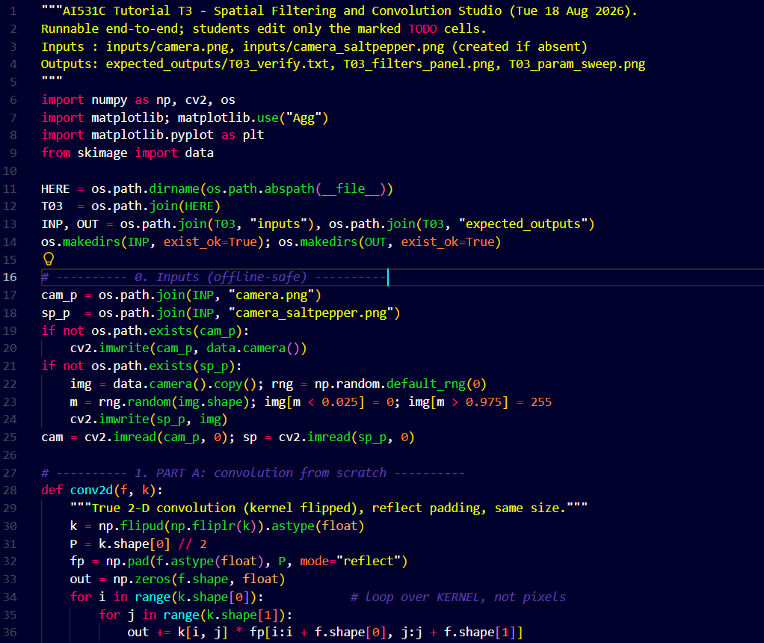
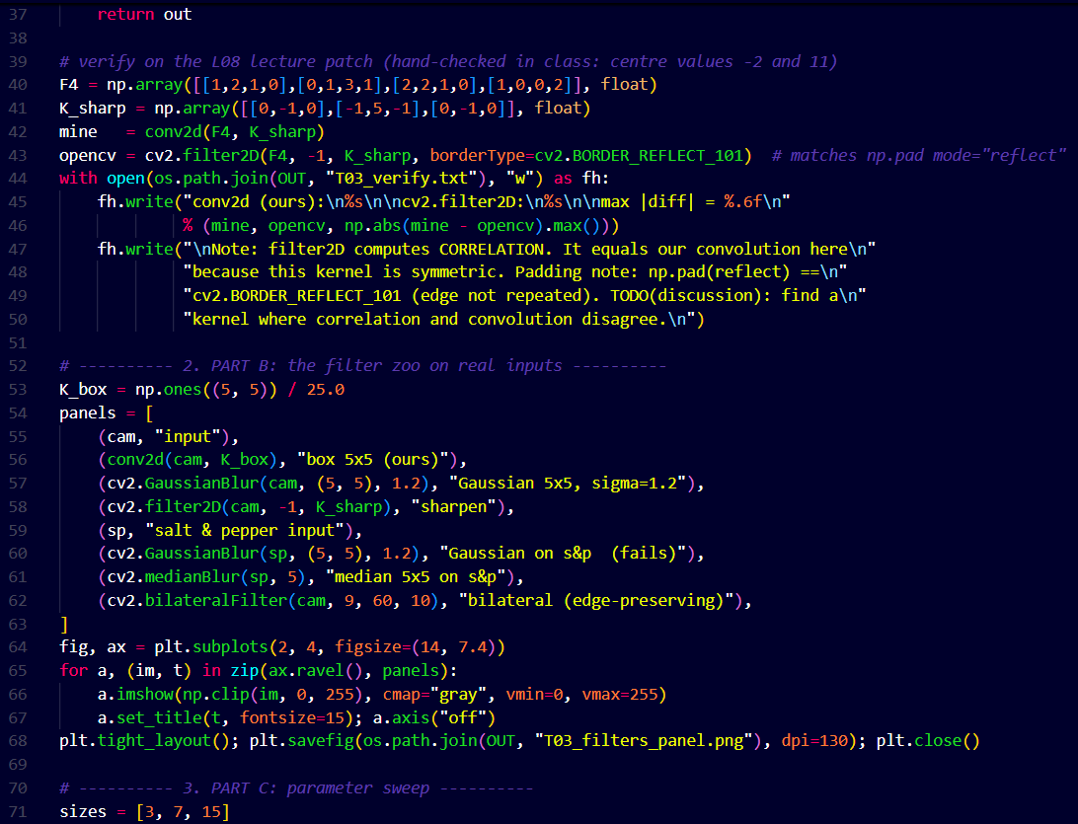
Digital Image Analysis Tutorial 2
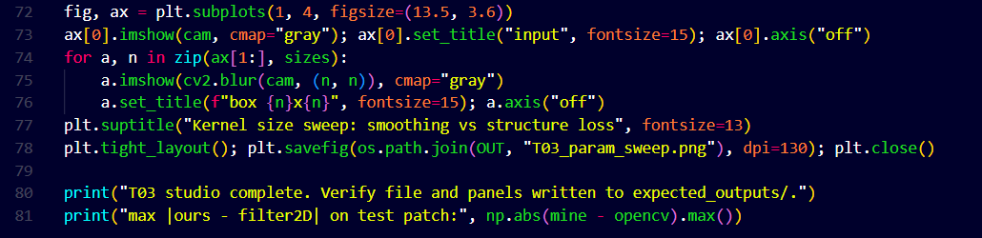

Output Images:
Filters Panel
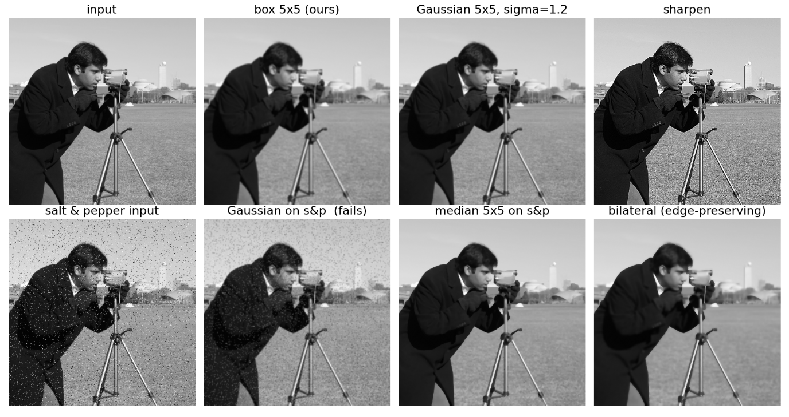

Parameter Sweep
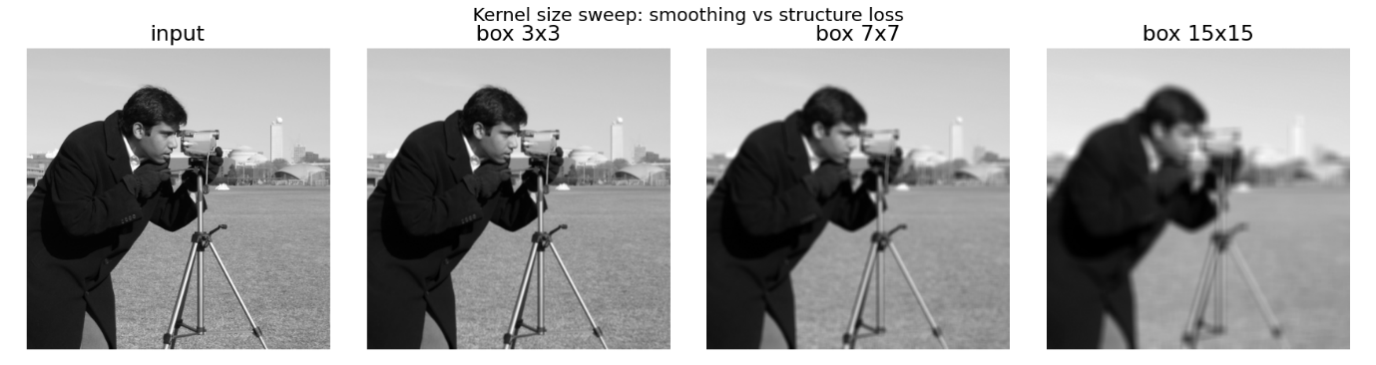

conv2d (ours):
[[ 1. 6. -3. -4.]
[-5. -2. 11. -1.]
[ 5. 6. 0. -5.]
[ 1. -5. -4. 10.]]

cv2.filter2D:
[[ 1. 6. -3. -4.]
[-5. -2. 11. -1.]
[ 5. 6. 0. -5.]
[ 1. -5. -4. 10.]]

max |diff| = 0.000000

